Rachel Pownall 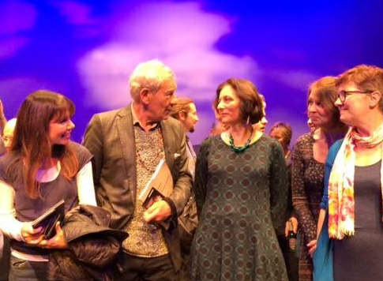
Email: rachellpownall@gmail.com With Sir Ian McKellen at the performance
Web: https://rachelpownall.weebly.com of my play, Limbo, at the Chesil Theatre, 2014.

Skills Summary
I am a writer, theatre maker and creative practitioner based in North Somerset with a long and varied career in the creative industries, from directing BBC TV documentaries to writing plays, film scripts, podcasts and short stories. I am currently developing an immersive theatre and creative technology project called Ghost Orchid and recently set up Agapanthus Productions. I am a qualified teacher with experience of lecturing and running practical workshops in film and media at FE and HE level, and I have an MA in Scriptwriting. Over the past three years I have been developing my own projects while working part-time for Bath Spa University, first as a Knowledge Exchange Manager on the government funded project South West Creative Technology Network (SWCTN) and now as Innovation Manager on MyWorld. Both programs aim to promote the use of creative technology in Bath, Bristol and beyond and involve working with multiple partners. I am also a Resident at The Studio in Bath, Bath Spa University’s creative technology, innovation and enterprise hub.

Education
2016–18 MA Scriptwriting (Merit), Bath Spa University
1996–97 Post Graduate Certificate in Education (English) (Passed), University of Bristol.
1985–86 Post graduate in Marketing and Media Studies at East Warwickshire College, Rugby leading to CAM Certificate in Communications, Advertising and Marketing (Gained) and RSA Personal Assistants’ Diploma (Gained)
  - BA Hons Degree: Drama & Theatre Studies (2:1), Royal Holloway, University of London.

Experience

Creative Projects
- Writer and Creative Director, Ghost Orchid project (ongoing)
- Wrote and directed the short film Mirror Image (2018)
- Wrote short play, Limbo, staged at Chesil Theatre as co-winner of their 10x10
competition (2014)
- Wrote short story, Night Shift, published in anthology The Clock Struck War, Mardibooks to commemorate centennial of outbreak of WW1 (2014)

Bath Spa University, Bath
- MyWorld, Innovation Manager, on UK Research & Innovation Funded project to promote screen-based innovation in Bristol and Bath (P/T, ongoing)
- SWCTN, Knowledge Exchange Manager on Research England Funded project to promote creative technology across the South West of England. (P/T, 2018 – 2021)

City of Bristol College, Bristol
2007 – date Program Lead for Foundation Degree in Digital Media Production, (in partnership with University of Plymouth)
Devised and ran the program, plus lectured, mentored and ran practical sessions in documentary and drama film making, and script writing.
2001 – 2008 Part-time Lecturer in Media
Teaching mature students on City & Guilds TV & Video Competencies and
16+ on BTec National Diploma (Media Moving Image)

Partridge Films, United Film & Media, HTV, Bristol
  - Television Producer
Directed 2 x 90min natural history documentaries Lethal Loners & Gang Killers

St Katherine’s School, North Somerset
  - Teacher of English and Drama (11 – 18 year olds)

BBC, Whiteladies Road, Bristol
  - Television Director, Television Features
Directed a variety of network tv documentaries for BBC1 and BBC2 including Poets News (BBC2), Festival of the Sea (BBC1) and Picture This – Internal Flight with poet Lemn Sissay (BBC2)
  - Television Researcher, including Words on Film (BBC2) and 999(BBC1)

1988-90 Television Production Assistant/Coordinator, Television Features
On Small Objects of Desire – Series 1 - 3 (BBC2) and Second Sight (BBC2)

  - Trainee Production Assistant, Natural History Unit, on Wildlife on One (BBC1
and Atlantic Realm (BBC2)
Secretary to Editor News, West, Points West

Awards and Acknowledgements
- British Medical Journal Award – Best Television Series for Men’s Health: Depression & Heart Disease (BBC2, 1996)

